A257-Afr-Egy-Ushabti-Late Period-Plain Lappet wig with 2 bands-Flat back-Hieroglyphs-Blue Faience

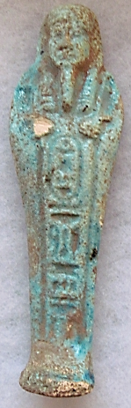 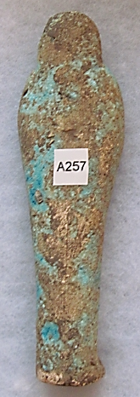

**Case No.: 2**

**Formal Label:** Ushabti-Late Period-Plain Lappet wig with 2 bands-Flat back-Hieroglyphs-Blue Faience

**Display Description: This** Ushabti of the Late Period has a Plain Lappet wig with 2 bands, Flat back-Hieroglyphs including a cartouche down the front and glazed in Blue Faience. The hands are opposed without sleeves with the right hand holding a holding a pick and the left holding a hoe.

**Accession Number: A257**

**LC Classification:** DT62

**Date or Time Horizon:** Late period, 525-334 BCE.

**Geographical Area: Saqqara, Egypt**

**Map, GPS Coordinates:** 29.85000 31.21667; [29°52′16″N 31°12′59″E](https://tools.wmflabs.org/geohack/geohack.php?pagename=Saqqara&params=29_52_16_N_31_12_59_E_type:landmark)

**Cultural Affiliation:** Late Period, Egypt, 525-334 BCE.

**Geographical Area: Saqqara, Egypt**

**Medium:** Faience

**Dimensions: H 192.16 mm, 7.57 in  
Weight:**

**Provenance: old European collection**

**Condition:** origina**l**

**Discussion:**

**References:**